Balachandran, Ryan
PHYS.1410L
Section 804
Instructor: Dr. Mittler

Introduction to Excel

Exercise 1: Velocity and Time

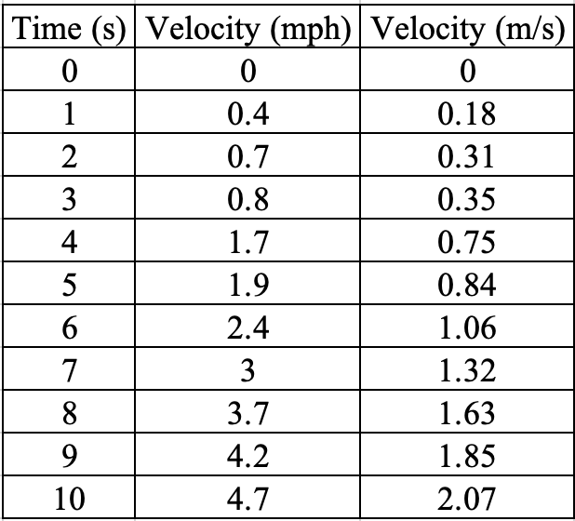

Unit conversion from mph (miles per hour) to m/s (meters a second) for Time 3:

$$0.8\frac{mile}{hour}×\frac{1,609.34 meters}{1 mile}×\frac{1 hour}{3,600 seconds}=0.3576\frac{meters}{second}$$

The data trend appears to rise at a fairly steady rate with no large jumps in numbers.
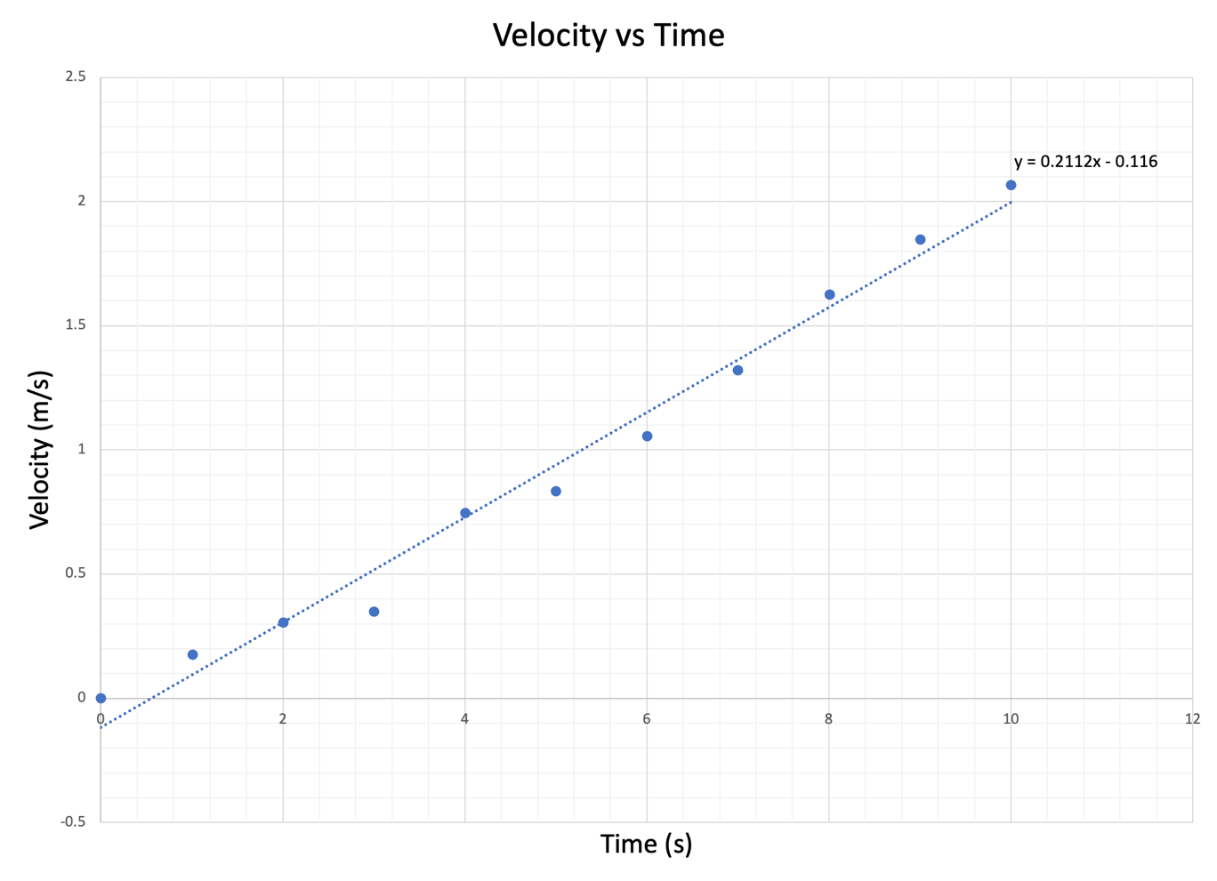
The trend seen on the graph is linear with no major deviations. The trend line is consistent with the expectation I had when viewing the data.

My interpretation of the slope is that the cart was given an initial velocity until it started to plateau, then received a push before its velocity steadily increased. With the slope being relatively steady, and the trend line being linear, the increase in velocity is seen to be almost constant.

Equation of the line is y = 0.2112x – 0.116

I found the equation of the slope by taking two arbitrary points on the trend line:

$$m=\frac{y2-y1}{x2-x1}$$

I then used one point (x, y) from the dataset and the slope and solved for the y-intercept b.

m (slope) = 0.2112
b = -0.116

$$y\left[\frac{m}{s}\right]=m\left[\frac{?}{?}\right]x\left[s\right]+b\left[\frac{m}{s}\right]$$

$$\frac{y}{x}\left[\frac{m}{s}÷s\right]=m\left[\frac{?}{?}\right]+\frac{b}{x}\left[\frac{m}{s}÷s\right]$$

m must be $m/s^{2}$

m (slope) = 0.2112 $m/s^{2}$

Exercise 2: Kinetic Energy and Time

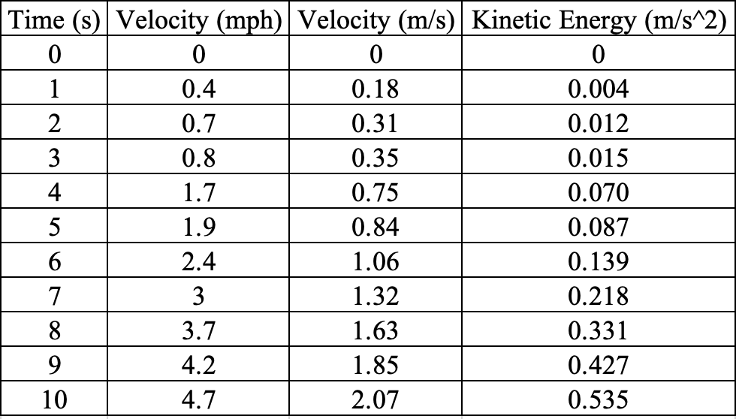

Sample calculation:

$$KE=\frac{1}{2}mv^{2}=\frac{1}{2}×0.25*{0.35}^{2}=\frac{1}{2}×0.25 × 0.1225=0.125 × 0.1225=0.015$$

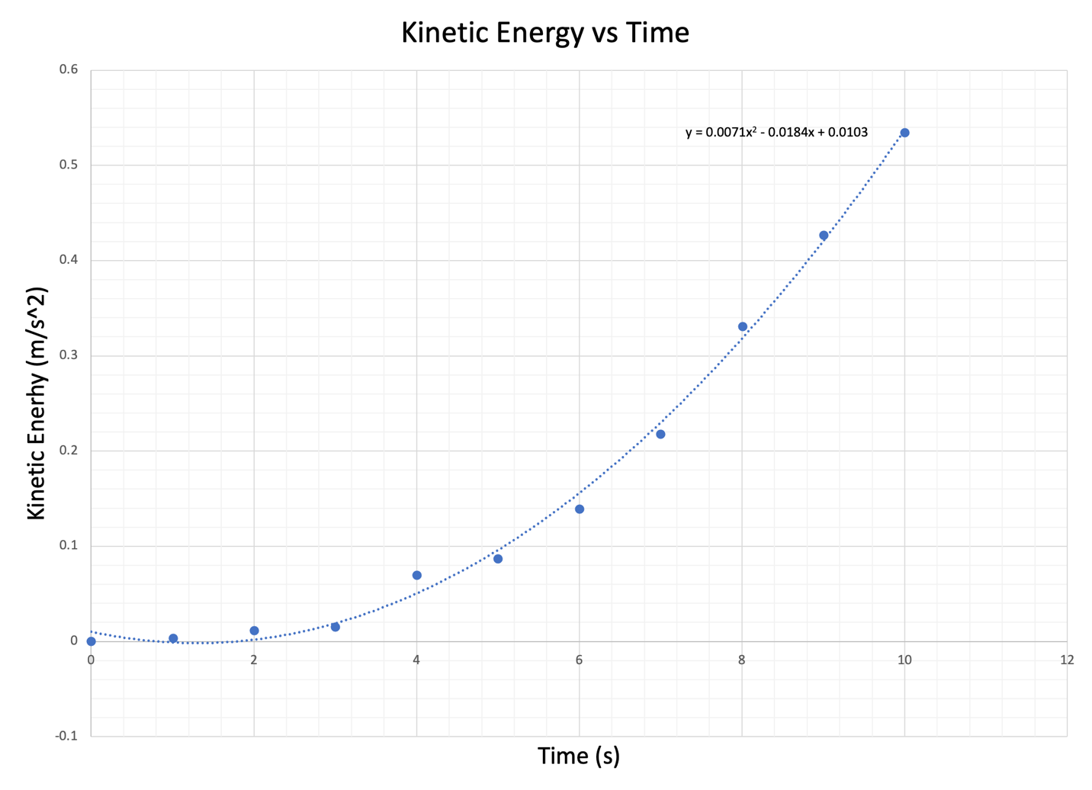
The trend line of this graph is curved. In relation to its velocity, the carts kinetic energy decreases very slightly in the beginning when the velocity of the cart is reaching the peak, then its kinetic energy increases (velocity squared) a lot as its velocity increases.

Kinetic energy is energy in motion and time is related to kinetic energy because if you cover the same distance in less time, then velocity and kinetic energy increases. The more velocity you have, the more kinetic energy will increase.

